

Brett Walton – Architect – bmw0045@auburn.edu

Christopher Burger – Requirements Engineer – cdb0076@auburn.edu

Christopher Moorhead – Project Manager – cam0071@auburn.edu

Collins Hess – Designer – cmh0098@auburn.edu

Grant Diamant – Prototype Designer – gmd0012@auburn.edu

Hunter Donald – QA Engineer – hzd0011@auburn.edu

**Table of Contents**

Domain Analysis ……………………...……………………………………………………… 3-6

Concept Statement ………………………………….………………………………….. 4

Conceptual Domain Model ………………………………….…………………………. 5

Domain State Model …………………………………………………………………… 6

Application Analysis ……………………………………..…………………...…………….. 7-50

Use cases ………………………………………………………………………………. 8

Application Interaction Model ……………...……………………………………….. 9-45

Essential Use Cases, Scenarios, High-level SSD

Concrete Use Cases, Detailed SSSD

Application Class Model ……………………………………………………………… 46

Application State Model …………………………………………………………… 47-50

Consolidated Class Model ………………………………………………………………...….. 51

Model Review ………………………………………………………...…………………… 52-53

**I. Domain Analysis**

**Concept Statement**

The Protecc Command Center is a home security system that permits the home-owner to monitor the exterior and interior of their property either directly through a PC or remotely via the internet. Command Center incorporates various devices that a home-owner can install in order to ensure the prevention of theft and the safety of their family. Among these devices are external cameras, smoke and gas leak detectors (these will always be on), motion sensors for doors and windows, and motorized locks for doors and windows. Command Center offers two different armed modes: home and away.

Home mode is meant to be used when the house is occupied. Away mode is meant to be used when the homeowner leaves the house for any amount of time. Each mode specifies the appropriate emergency service for a situation. If the mode is set to home and an alarm is triggered, then the emergency services are called and know to expect people at home and should be prepared to protect them. In away mode, if the home owner is returning home or if they are expecting a visitor while they are gone, then they have a few seconds to enter the correct password on the control panel inside the home or through the online application to disable the alarm before emergency services are called. Emergency services should expect that somebody is breaking in if they are contacted in away mode. Therefore, the only difference between home and away mode is that emergency services are called immediately if an alarm is triggered in home mode, but a few seconds are given before emergency services are called in away mode to allow time for deactivation.

The cameras are installed around home entry points and provide constant surveillance. The Command Center allows direct access to any of the camera feeds for the home-owner. When cameras detect motion**,**they immediately notify the user and send a picture of the intrusion.

Command Center utilizes motion sensors which detect if a door or window is open or if there is movement coming through either. Abnormal readings for these sensors default to sending notifications to the user through system notifications. If the house is in home or away mode, these motion sensors will be armed.

 The Command Center also includes motorized locks for doors and windows. Through the Command Center interface, the home-owner can see what doors and windows are locked or unlocked. In away and home mode, all doors and windows are locked. If the house is disarmed, the homeowner can still choose to do any of the following: lock them all through a “Lock” command, unlock them all through an “Unlock” command, or lock/unlock them all individually. The doors can be manually unlocked as well without the application but the home-owner will be notified if any doors or windows open without using the application.

The Command Center application gives the home-owner control of what they see and when they see it. Upon entering the application, the home-owner is shown the most recent and important notifications. If there are images associated with the notification, such as via the video feed, then the home-owner can easily expand the notification to view it. From the main menu, the home-owner can access settings or view a live feed of sensor data.

There are many settings within the Command Center that the home-owner can adjust. The primary setting is how they want to receive notifications and which ones they prioritize. Similarly, the home-owner can set up the system to automatically notify the authorities for specific sensor readings. If a gas leak is detected or a smoke alarm stays on for a certain duration of time, then the fire department can be alerted. Or if a person is detected attempting to break into the home then the police department can be immediately notified.

**Concept Domain Model**

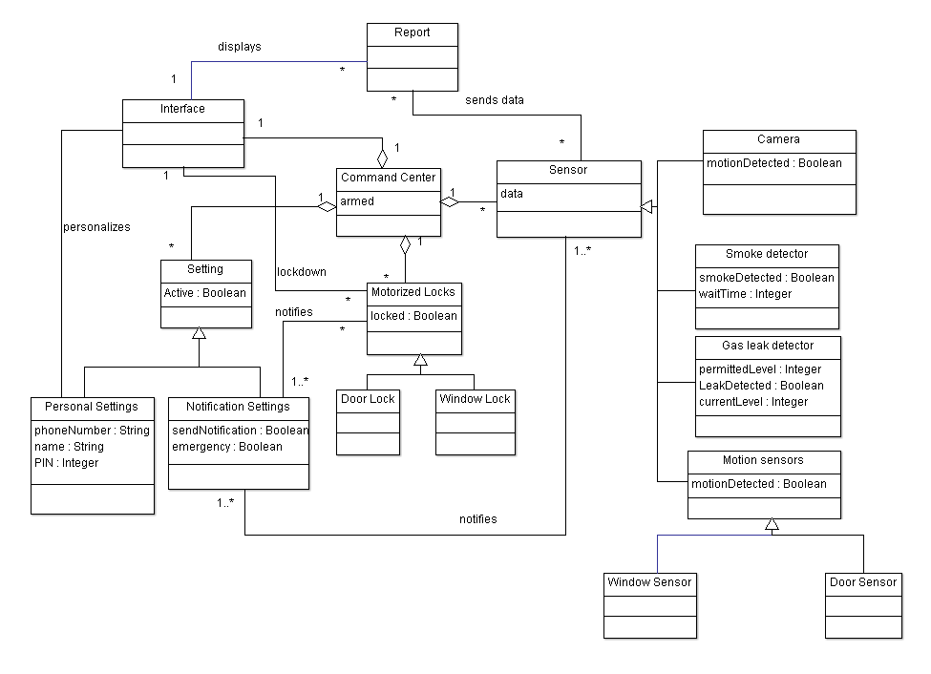

**Domain State Model**

**System**

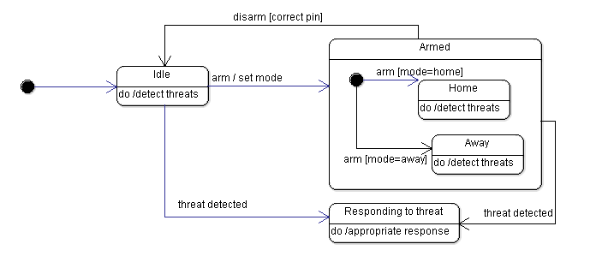

**Sensor**

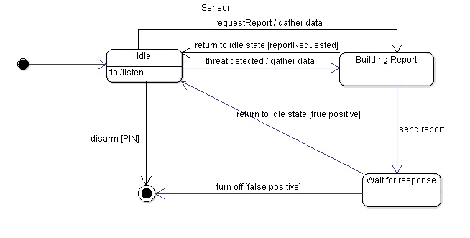

**II. Application Analysis**

**Application Interaction Analysis**

**Use Cases**

**1.** View Live Feed …………………………………………………………………………. 9

**2.** Contact Emergency Services …………………………………………………...……..... 12

**3.** Lockdown .….………………………………………………………………………...... 15

**4.** View Report ……………………………………………………..……………………... 18

**5.** Trigger Alarm…………………………………………………………………………… 21

**6.** Turn Off Alarm ……………………...…………………………………………………. 24

**7.** Add Sensor ……………………………………………………....…………………..…. 27

**8.** Remove Sensor ………………………………………………………………………..... 30

**9.** Arm System ...................................................................................................................... 33

**10.** Adjust Settings ................................................................................................................ 36

**11.** Add to Report …............................................................................................................. 39

**12.** Disarm System ............................................................................................................... 43

**.**

**.**

**.**

Application Class Model ………………………………………………………………….. 46

Application State Model …………………………………………………………………... 47-50

Consolidated Class Model ……………………………………………………………….... 51

Model Review ………………………………………………………...…………………… 52-53

**Use Case:** View Live Feed

**Essential Use Case:**

**Participants:** Home-owner

**Pre-conditions:** Home-owner has devices set up.

**Typical Course of Events:**

|  |  |
| --- | --- |
| **Actor Intention** | **System Responsibility** |
| 1. Access application  3. Choose option to view feed  5. Select device  7. View feed  8. Exit feed | 2. Show interface  4. List devices with feeds to show  6. Show live feed of device  9. List devices with feeds to show |

**Exceptions:**

**Step 4:** No devices to show. Show error message and return to initial interface.

**Post-condition:** Home-owner has viewed feed (if available) and exited the feed.

**Scenario:**

Home-owner access application.

System shows interface.

Home-owner chooses to view live feed.

System shows a list of devices with feeds to show.

Home-owner selects camera feed.

System shows the live camera footage.

Home-owner views footage.

Home-owner exits feed.

System returns to list of devices.

**High Level System Sequence Diagram:**

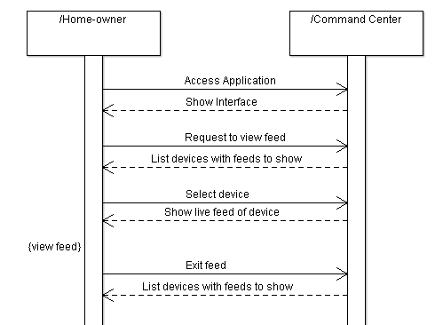

**Concrete Use Case:**

|  |  |
| --- | --- |
| *Use case name* | ViewLiveFeed |
| *Entry condition* | 1. The HomeOwner accesses the CommandCenter and presses the “View Live Feeds” button. |
| *Flow of events* | 2. The CommandCenter displays an interface that lists the available devices to view the live feeds for. There is also an option to just view all current readings.  3. The HomeOwner selects the devices that they would like to view the feed for by pressing its respective button. The device’s live results are then accessed by the CommandCenter.  4. The CommandCenter displays an interface that shows the live feed for the device. If the device is a camera, then the camera feed is shown. If it is a sensor monitoring some levels, it shows the current reading, expected reading, and a graph showing the level variation over the last few hours. If the user chooses the option to view all current readings, a similar display to this is shown that includes the data for all of the monitoring sensors. |
| *Exit condition* | 5. The HomeOwner exits the live feed. |

**Detailed System Sequence Diagram:**

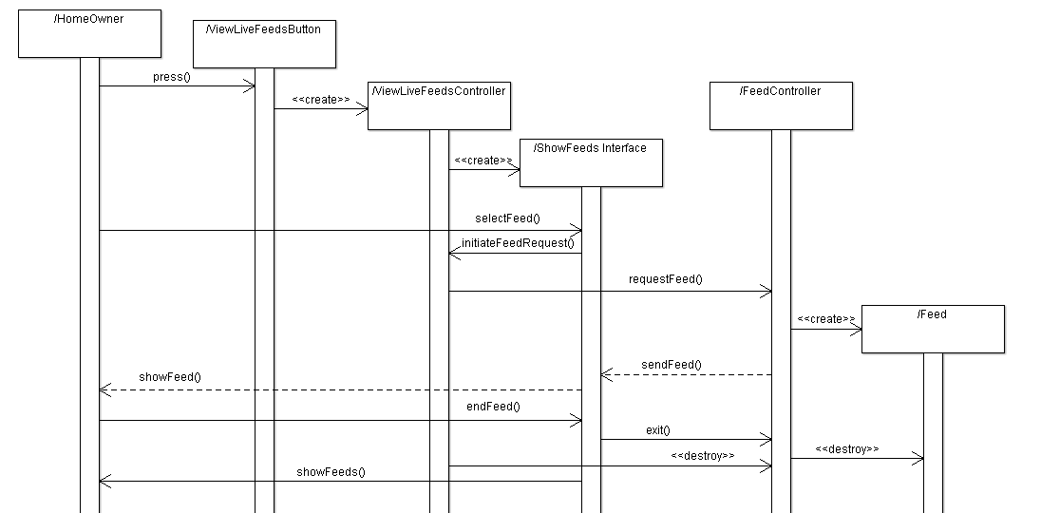

**Use Case:** Contact Emergency Services

**Essential Use Case:**

**Participants:** Home-owner, Emergency Services

**Pre-conditions:** System sends a notification to the home-owner about a potential reason to contact emergency services.

**Typical Course of Events:**

|  |  |
| --- | --- |
| **Actor Intention** | **System Responsibility** |
| 3. Review the notification.  4. Tell system to contact emergency services. | 1. A sensor detects an issue that requires attention.  2. Notify the home-owner of the problem and recommend action.  5. Contact emergency services and send a report to assist them.  6. Tell home-owner help is on the way. |

**Exceptions:**

* **Step 4:** Decide no actions are required. Do not contact emergency services. Skip step 5-6.
* **Step 5:** Fail to contact emergency services. Tell home-owner.

**Post-condition:** Emergency services have been called.

**Scenarios:**

System detects an issue that requires attention.

System notifies home-owner of the problem and delivers a recommended action.

Home-owner reviews the notification.

Home-owner tells the system to contact emergency services.

System contacts emergency services and sends a report to assist them.

System confirms to home-owner that help is on the way.

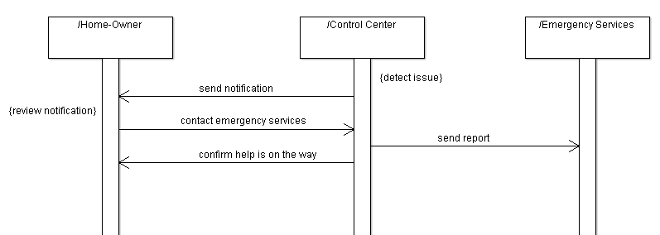**High Level System Sequence Diagram:**

**Concrete Use Case:**

|  |  |
| --- | --- |
| *Use case name* | ContactEmergencyServices |
| *Entry condition* | 1. The CommandCenter identifies an issue that may require emergency services to be called. |
| *Flow of events* | 2. The CommandCenter notifies the HomeOwner of the issues that it identified.  3. The HomeOwner reviews the issue and decides whether to call for help. Typically, the HomeOwner will review the issue and decide that emergency services should be called.  4. The CommandCenter contacts EmergencyService and sends an EmergencyReport that lists the issue and provides as much assistance to the EmergencyService as needed. The EmergencyService then confirms that help is being sent to CommandCenter.  5. CommandCenter notifies HomeOwner that help is on the way. |
| *Exit condition* | 6. EmergencyService is on the way. |

**Detailed System Sequence Diagram:**

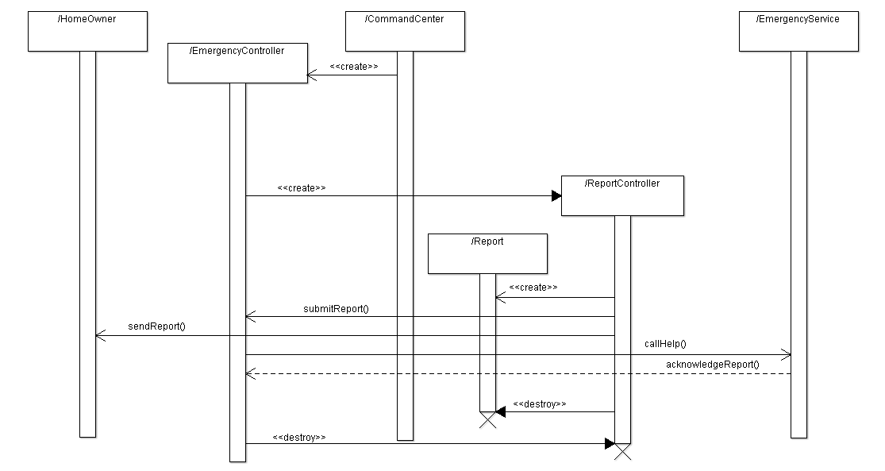

**Use Case:** Lockdown

**Essential Use Case:**

**Participants:** Home-owner

**Pre-conditions:** Mechanical locks installed.

**Typical Course of Events:**

|  |  |
| --- | --- |
| **Actor Intention** | **System Responsibility** |
| 1. Access application.  3. Initiate lockdown.  7. Exit application. | 2. Display interface.  4. Activate mechanical locks.  5. Once locks have stopped, check that all entries have successfully locked.  6. All entries are locked, success notification sent to home-owner. |

**Exceptions:**

* **Step 5:** An entry failed to lock. The process stops and the home-owner is notified of which entry was not successfully locked.

**Post-condition:** Report saved.

**Scenario:**

Home-owner accesses application.

System displays main interface.

Home-owner initiates lockdown.

System activates all mechanical locks not currently in a locked state.

Once locks have stopped, system confirms that the entries have successfully locked.

System sends home-owner a confirmation message.

Home-owner exits application.

**High Level System Sequence Diagram:**

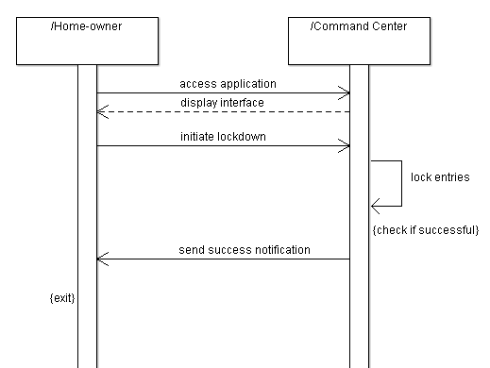

**Concrete Use Case:**

|  |  |
| --- | --- |
| *Use case name* | Lockdown |
| *Entry condition* | 1. HomeOwner initiates lockdown. |
| *Flow of events* | 2. CommandCenter initiates lockdown by activating the mechanical locks on the entries.  3. CommandCenter waits until the locks stop moving.  4. CommandCenter checks the status of all the locks.  5. All entries are confirmed as locked. |
| *Exit condition* | 6. CommandCenter sends a success message to HomeOwner. |

**Detailed System Sequence Diagram:**

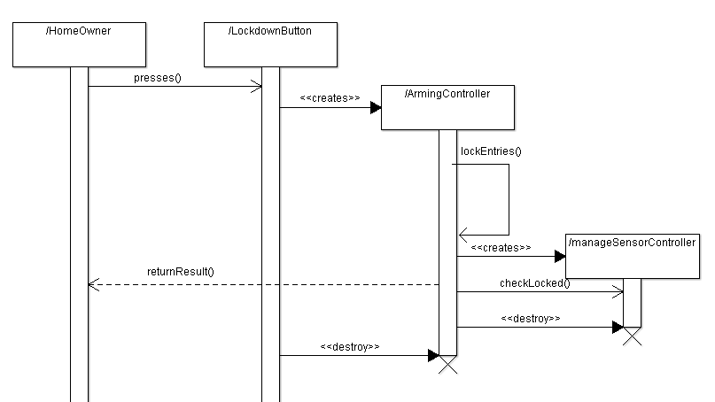

**Use Case:** View Report

**Essential Use Case:**

**Participants:** Home-owner (User)

**Pre-conditions:** Protecc system is running

**Typical Course of Events:**

**Actor Intention System Responsibility**

1. Access application.

2. Display Interface

3. User selects View Report

4. Notification Report is displayed

5. Review the report log

6. Exit Report

**Exceptions:**

* **Step 5:** User selects notification, where it can be seen before exiting back to report.

**Post-condition:** User has viewed and exited report log.

**Scenario**

User logs in to application.

The Command Center pulls up the interface and options.

User chooses to view report.

The Command Center displays the report for the user.

The User views and selects any notifications they deem important.

The User selects to exit the report.

The Command Center exits to the main menu screen.

**High Level System Sequence Diagram**

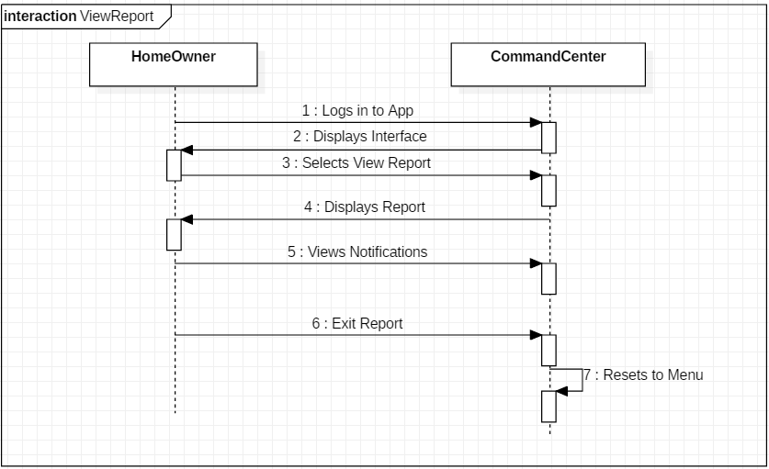

**Concrete Use Case:**

|  |  |
| --- | --- |
| *Use case name* | View Report |
| *Entry condition* | 1. A user is logged in to the system |
| *Flow of events* | 2. The Command Center displays the interface to the user  3. The User selects the option to View Report  4. The Command Center displays a report of notifications  5. The User views the notifications as requested  6. The User selects to exit the report |
| *Exit condition* | 7. The Command Center displays the main menu |

**Detailed System Sequence Diagram:**

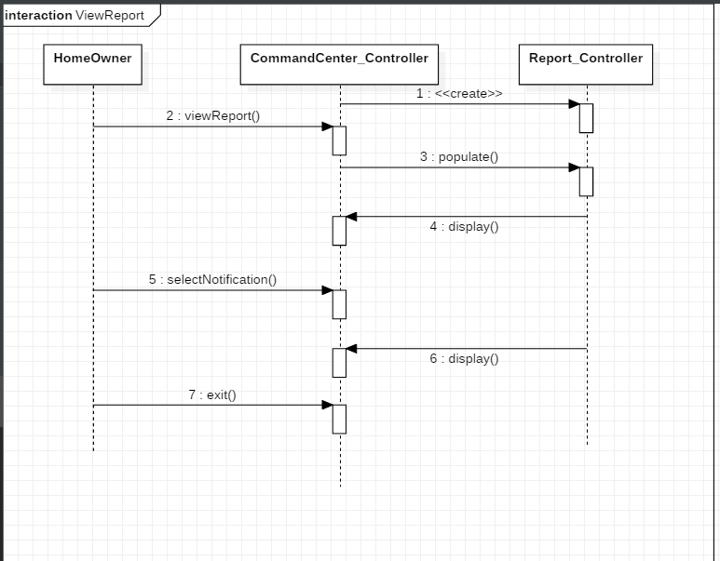

**Use Case:** Trigger Alarm

**Essential Use Case:**

**Participants:** Homeowner, Command Center

**Pre-conditions:** The system is armed.

**Actor Intentions System Responsibility**

1. A sensor detects an issue that requires attention.

2. Determines system is in away mode.

3. Responds with correct alarm timing

4. Asks for safety verification

6. Contact Emergency Services

**Exceptions:**

2. Determines system is in home mode and immediately triggers the alarm.

5. The user does not enter the correct verification and the alarm is immediately triggered.

5. Enter safety verification

**Exceptions:**

* **Step 2:** Determines system is in home mode and immediately triggers the alarm.
* **Step 5:** The user does not enter the correct verification and the alarm is immediately triggered.

**Post Condition:** The alarm is correctly triggered.

**Scenario:**

The system detects an issue from a sensor and begins to trigger the alarm. If in away mode, the user will have a short amount of time to enter their information before the alarm is triggered. Otherwise, the alarm is triggered, and the Contact Emergency Services sequence begins.

**High Level System Sequence Diagram:**

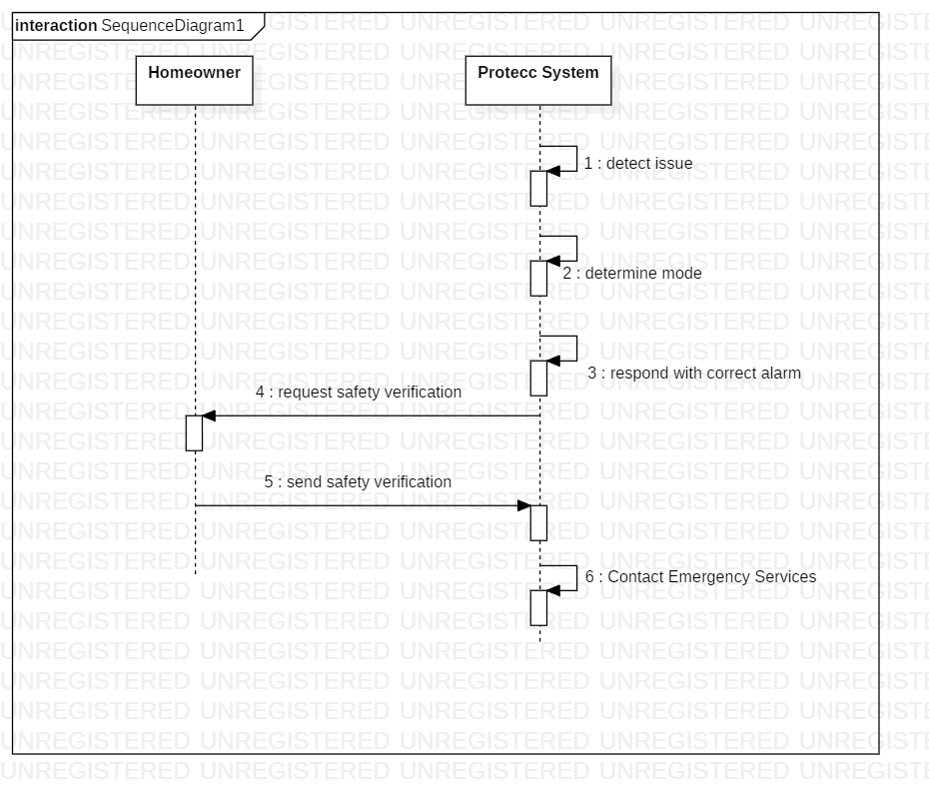

**Concrete Use Case:**

|  |  |
| --- | --- |
| *Use case name* | Trigger Alarm |
| *Entry condition* | 1. A detector is tripped while the system is activated. |
| *Flow of events* | 2. The CommandCenter determines that the system is armed and releases a warning that the alarm is about to be triggered.  3. The system asks for the homeowner’s personal information to verify the homeowner is safe and not in danger  4. The homeowner does not enter their correct information within the allotted amount of time.  5. The system triggers the alarm and waits for further instructions. |
| *Exit condition* | 6. The system starts the Contact Emergency Services sequence. |

**Detailed System Sequence Diagram:**

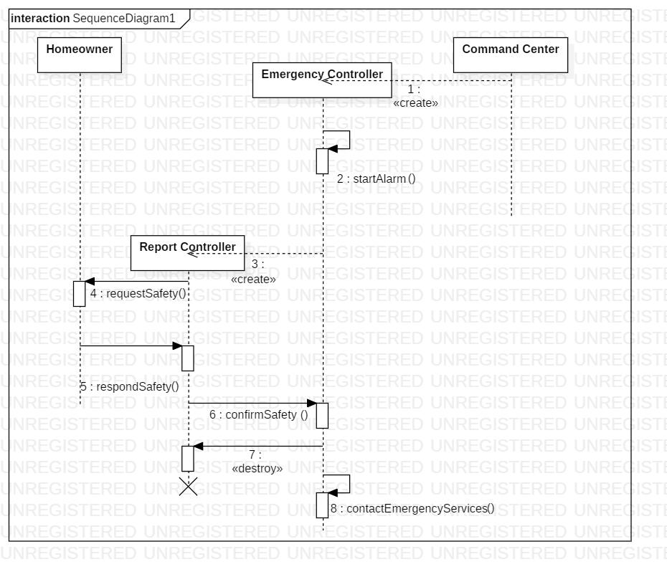

**Use Case:** Turn off Alarm

**Essential Use Case:**

**Participants:** Homeowner, Command Center

**Pre-conditions:** The alarm is triggering.

**Actor Intentions System Responsibility**

3. Replies that the home is safe.

1. Displays current alarm status.
2. Requests verification of safety
3. Alarm is deactivated.

**Exceptions:**

* **Step 3:** Homeowner does not reply that they are safe, and the alarm is not deactivated.

**Post Condition:** Alarm is turned off.

**Scenarios:**

If the alarm is triggered and the system is in away mode, the system will warn the homeowner about the alarm. The homeowner has a short amount of time to disable the alarm otherwise it will be set off. The homeowner then has to correctly enter their information in order to deactivate the alarm.

**High Level System Sequence Diagram:**

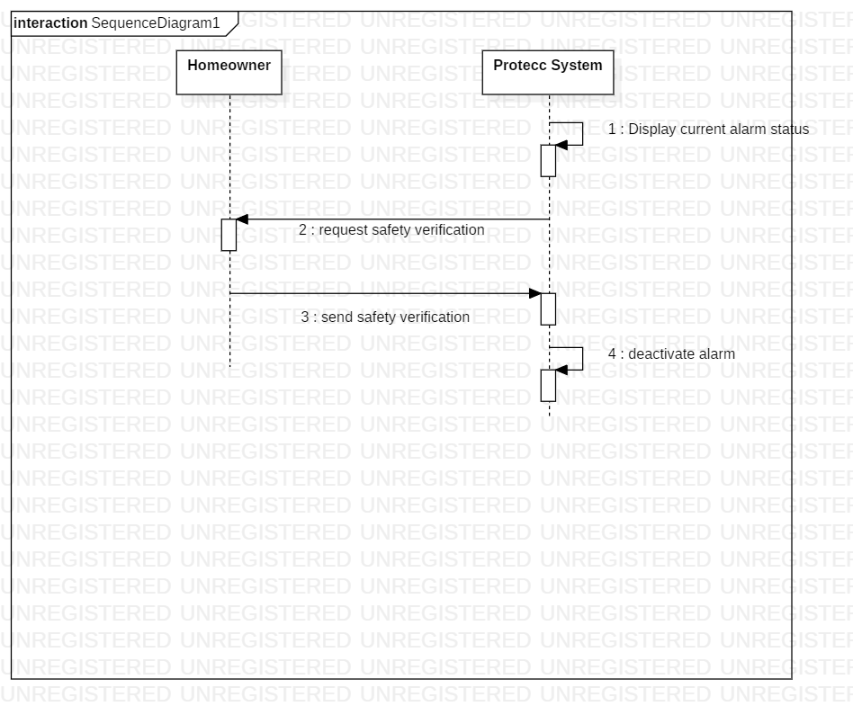

**Concrete Use Case:**

|  |  |
| --- | --- |
| *Use case name* | TurnOffAlarm |
| *Entry condition* | 1. A detector is triggered while the system is activated. Alarm is on. |
| *Flow of events* | 2. The CommandCenter displays current status and that the alarm is triggered.  3. The system asks for the homeowner’s personal information to verify the homeowner is safe and not in danger  4. The homeowner enters the correct PIN.  5. The system disables the alarm. |
| *Exit condition* | 6. The system resets to an unarmed state. |

**Detailed System Sequence Diagram:**

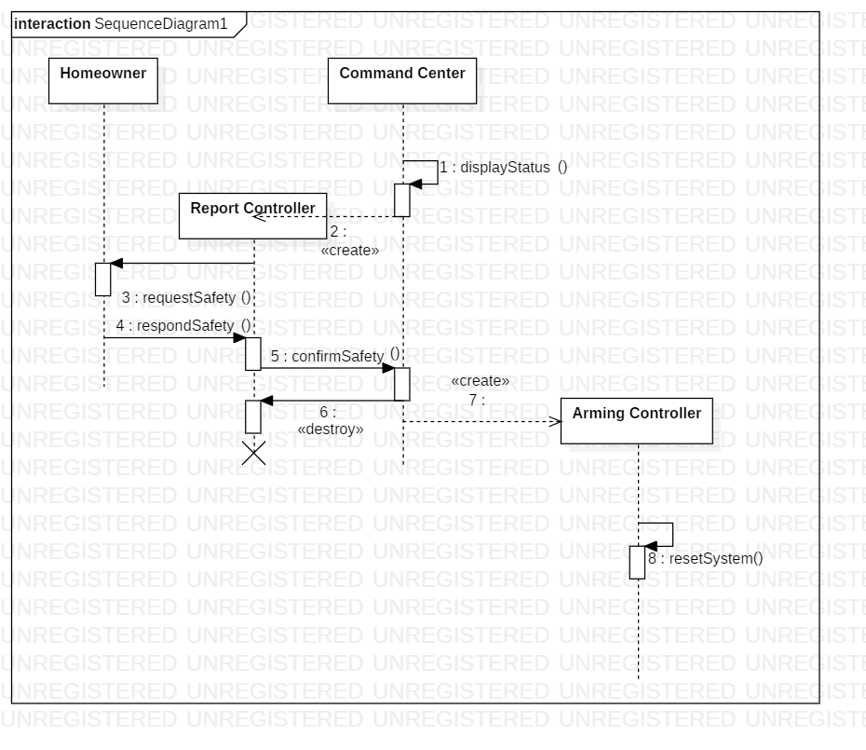

**Use Case:** Add Sensor

**Essential Use Case:**

**Participants:** Home-owner

**Pre-conditions:** The protecc system is set up and running

**Typical Course of Events:**

**Actor Intention System Responsibility**

1. Access Command Center

2. Show Interface

3. Choose option to add sensor

4. Show which type of sensor you would like to add

5. Choose sensor type

6. Show message enter serial number

7. Enter serial number of the sensor

8. Adds new sensor

9. Show message successfully added

10. Exits to main menu

**Exceptions:**

**-**Step 5. If the user tries to add the wrong type of sensor it will not pair.

-Step 7**.** If the user enters the wrong serial number, the sensor will not pair with the system.

**Post-conditions**: The serial numbers are visible.

**Scenario:**

Home-owner accesses Command Center.

The Command Center pulls up an interface with options.

Home-owner choses add sensor.

The Command Center asks the user what type of sensor they would like to add.

The Home-owner then choses sensor type.

The Command Center then tell user to enter serial number of the sensor.

The Home-owner enters serial number of the sensor.

The Command center adds the sensor.

The Command Center then displays whether the pairing of the sensor is successful or failed.

The Home-owner then exits to the main menu.

**High Level System Sequence Diagram**

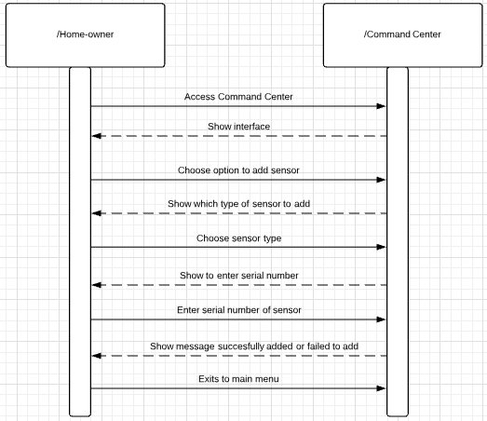

**Concrete Use Case:**

*Use Case* Add Sensor

*Entry Conditions* 1. The Home-owner accesses the Command Center and presses the “Add

Sensor” button.

*Flow of Events*  2. The Command Center displays an interface asking what type if sensor you want to add.

3. The Home-owner selects the type of sensor they are adding.

4. The command center displays a message asking them to enter the serial number of the sensor.

5. The Home-owner then enters the serial number of the sensor for pairing.

6. The Command Center then displays a message saying whether the pairing of the sensor was successful or failed.

*Exit conditions* 7. The Home-owner then exits to the main menu of the Command Center.

**Detailed System Sequence Diagram:**

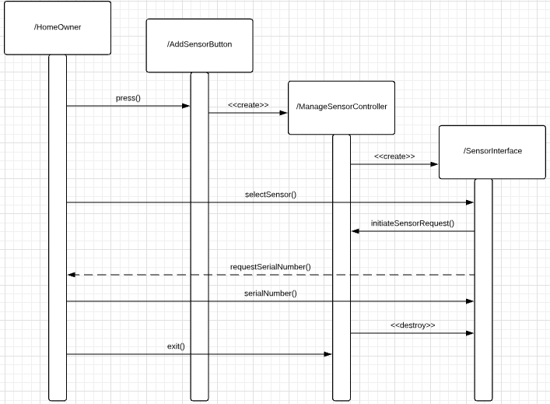

**Use Case:** Remove Sensor

**Essential Use Case**

**Participants:** Home-owner

**Pre-conditions:** The protecc system is set up and running

**Typical Course of Events:**

**Actor Intention System Responsibility**

1. Access Command Center

2. Show interface

3. Choose option to remove sensor

4. Displays message select which sensor you want to remove

5. Select the sensor you want to remove

6. Prompts home-owner to enter password

7. Enters password

8.Removes selected sensor

9. Displays message sensor removed

10. Exits to main menu

**Exceptions:**

-Step 7**.** If the home-owner enters the wrong password the sensor will not be removed.

**Post-conditions**: Removed sensor must be deleted from system.

**Scenario:**

Home-owner accesses Command Center.

The Command Center pulls up interface with options.

Home-owner choses remove sensor.

The Command Center prompts home-owner to select which sensor they would like to remove

The home-owner then selects which sensor to remove.

The Command Center prompts home-owner for password

The home-owner then enters the password.

The Command Center then removes the selected sensor.

The Command Center displays a message that the sensor was removed.

The home-owner exits to main menu.

**High Level System Sequence Diagram:**

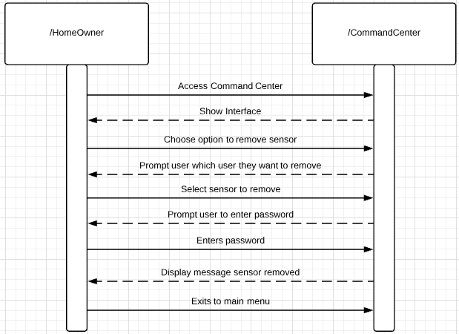

**Concrete Use Case:**

*Use case name* Remove Sensor

*Entry Condition* 1. The Home-owner accesses the Command Center and presses the “Remove Sensor” button.

*Flow of Events* 2. The Command Center prompts what sensor would you like to remove.

3.The Home-owner then selects which sensor he wants to remove.

4. The command center then asks for a password.

5. The home-owner enters the password.

6. The command center displays message the sensor was removed.

*Exit conditions* 7. The home-owner exits to the main menu

**Detailed System Sequence Diagram:**

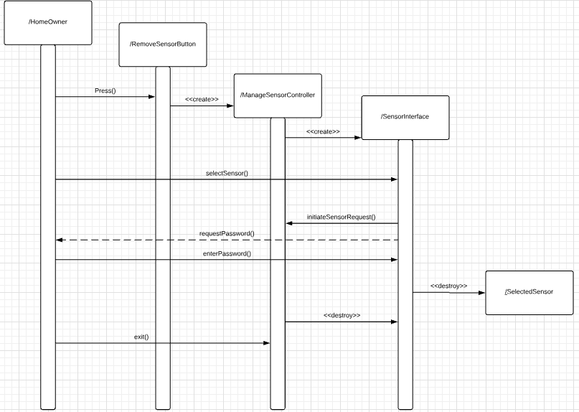

**Use Case:** Arm System

**Essential Use Case:**

**Participants:** Home-owner, Command Center

**Pre-conditions:** Homeowner decides to arm system to away mode.

**Typical Course of Events:**

|  |  |
| --- | --- |
| **Actor Intention** | **System Responsibility** |
| 1. Accesses application.  3. User selects away mode.  7. Exits application. | 2. Displays interface  4. System arms house in away mode.  5. Motion sensors and doors/windows are locked.  6. Display to user that house has been put in away mode. |

**Exceptions:**

* **Step 1:** Home mode is activated.

**Post-condition:** Away mode has been activated

**Scenarios:**

|  |
| --- |
| The user decides to arm the house in away mode while he/she is out of town.  User opens application.  The system displays the available modes to put the house in.  User selects to put the house in away mode.  System arms house in away mode.  System activates motion sensors and locks windows/doors.  User closes application. |

**High Level System Sequence Diagram:**

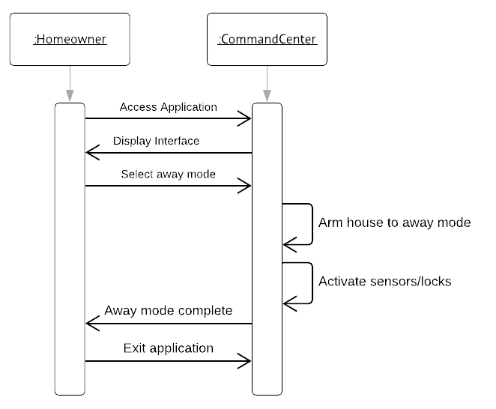

**Concrete Use Case:**

|  |  |
| --- | --- |
| *Use case name* | ArmHouseToAwayMode |
| *Entry condition* | 1. The homeowner wishes to arm their house to away mode while on vacation. |
| *Flow of events* | 2. The homeowner opens the Command Center application via the internet.  3. The Command Center displays a main menu with options to arm house. Within the arm house menu is where user can select away mode.  4. Homeowner selects the “Away Mode” button.  5. Command Center changes house to away mode, which means all sensors are activated and all locks are locked.  6. Command Center notifies user that house is in away mode.  7. User exits the online application |
| *Exit condition* | 6. House is in away mode. |

**Detailed System Sequence Diagram:**

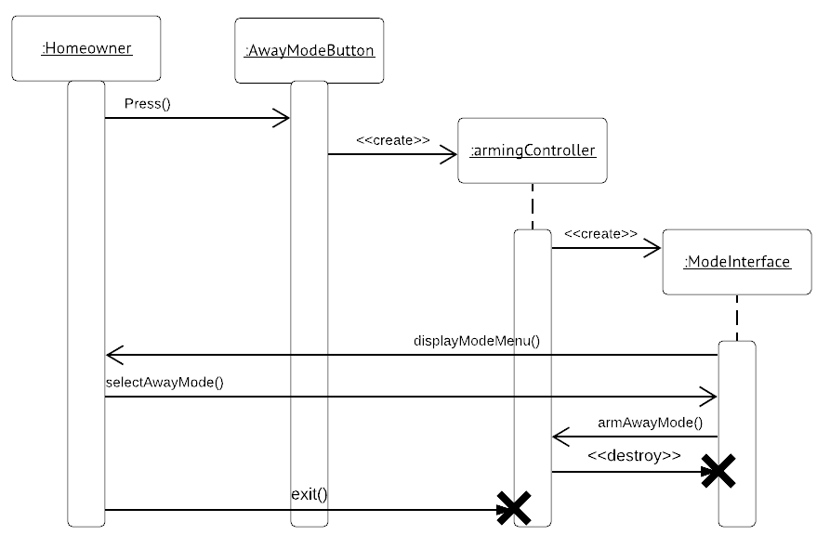

**Use Case:** Adjust Settings

**Essential Use Case:**

**Participants:** Home-owner, Command Center

**Pre-conditions:** Homeowner changes notification settings.

**Typical Course of Events:**

|  |  |
| --- | --- |
| **Actor Intention** | **System Responsibility** |
| 1. Accesses application.  3. Select settings.  5. Selects appropriate setting option to change.  7. Exits application. | 2. Displays interface  4. Displays list of settings options.  6. Changes settings as requested by user. |

**Exceptions:**

* **Step 5:** Setting options include notification hierarchy and when emergency services should be called.

**Post-condition:** Settings have been changed or remain the same.

**Scenarios:**

|  |
| --- |
| The user decides to change the notification settings  User opens application.  The system displays a main menu.  User selects the settings option.  A settings menu appears.  User chooses to change notification hierarchy.  User is prompted to save changes to settings.  User selects yes and closes the application |

**High Level System Sequence Diagram:**

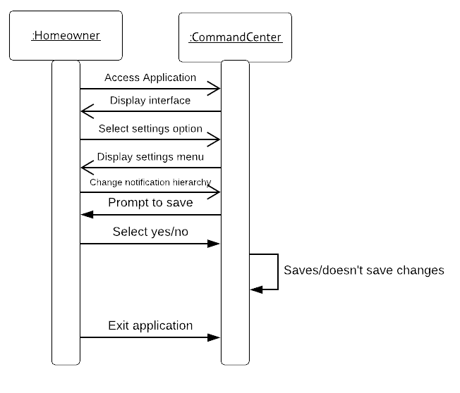

**Concrete Use Case:**

|  |  |
| --- | --- |
| *Use case name* | AdjustCameraSettings |
| *Entry condition* | 1. The homeowner wishes to not be notified every time a camera captures a person outside of the house except when in home/away mode. |
| *Flow of events* | 2. The homeowner opens the Command Center application via the internet.  3. The Command Center displays a main menu.  4. Homeowner selects the “Settings” option button.  5. Homeowner selects “Camera Settings” within settings.  6. Homeowner changes notification settings for the camera.  7. System prompts user to save changes.  7. User saves changes and exits the online application. |
| *Exit condition* | 6. Camera settings are changed. |

**Detailed System Sequence Diagram:**

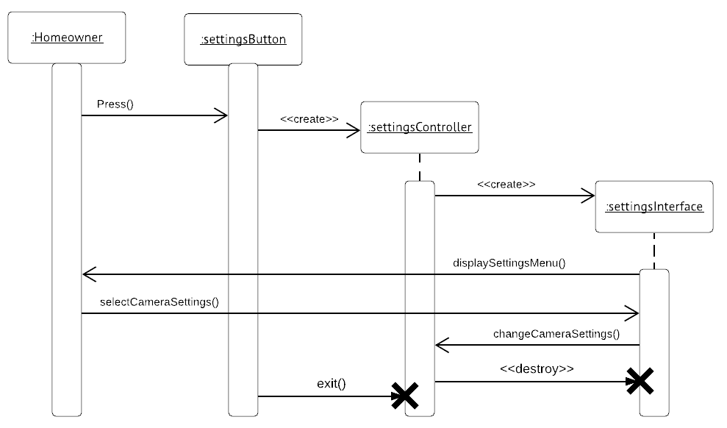

**Use Case:** Add to Report

**Essential Use Case:**

**Participants:** Home-owner

**Pre-conditions:** An issues has occurred.

**Typical Course of Events:**

|  |  |
| --- | --- |
| **Actor Intention** | **System Responsibility** |
| 1. Sensor tripped or alarm triggered. | 2. Add what happened to report.  3. Save report. |

**Exceptions:**

* **Step 5:** Setting options include notification hierarchy and when emergency services should be called.

**Post-condition:** Report has been saved.

**Scenarios:**

|  |
| --- |
| A camera detects motion.  System adds to the report that the camera detected motion at a certain time then saves the report.  Smoke Detector detects that there is too much smoke.  System adds to the report that there was too much smoke at a certain time then saves the report.  Gas Leak Detector detects a gas leak somewhere inside the house.  System adds to the report that there was a gas leak at a certain time then saves the report.  An intrusion detector detects an intrusion into the house.  System adds to the report that there was an intrusion at a certain time then saves the report. |

**High Level System Sequence Diagram:**

**Concrete Use Case:**

**Actor Intentions System Responsibility**

1) Smoke Detector is triggered. 2) System adds that the Smoke Detector was triggered, and the time it was triggered.

3) System saves the report.

**Actor Intentions System Responsibility**

1) Gas Leak Detector is triggered. 2) System adds that the Gas Leak Detector was triggered, and the time it was triggered.

3) System saves the report.

**Actor Intentions System Responsibility**

1) A camera detects motion. 2) System adds that one of the cameras has detected motion.

3) System saves the report.

**Actor Intentions System Responsibility**

1) Intrusion Detector detects motion. 2) System adds that there was an intrusion, and the time the intrusion occurred. Report saved.

**Detailed System Sequence Diagram:**

**Use Case:** Disarm System

**Essential Use Case:**

**Participants:** Home-owner

**Pre-conditions:** System is armed.

**Typical Course of Events:**

|  |  |
| --- | --- |
| **Actor Intention** | **System Responsibility** |
| 1. Access interface.  2. Select to disarm system.  4. Present PIN. | 3. Prompt for PIN.  5. Disarm. |

**Exceptions:**

* **Step 5:** Presented PIN is incorrect. Fails to disarm and will signal an alarm and create an emergency report if it is not fixed.

**Post-condition:** System disarmed.

**Scenarios:**

|  |
| --- |
| Home-owner comes home to an armed system.  Walks into the house, alarm tripped.  Home-owner goes to Command Center house terminal.  Home-owner presses disarm button.  CommandCenter prompts home-owner for a PIN.  Home-owner enters correct PIN.  Alarm stops, system is disarmed. |

**High Level System Sequence Diagram:**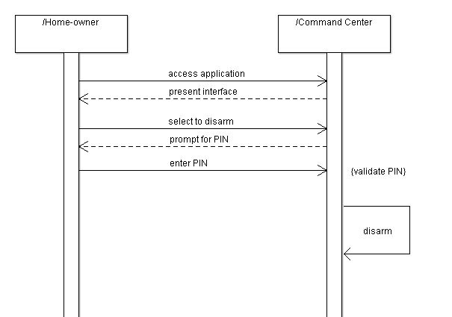

**Concrete Use Case:**

|  |  |
| --- | --- |
| *Use case name* | DisarmSystem |
| *Entry condition* | 1. CommandCenter is armed to home or away mode. |
| *Flow of events* | 2. HomeOwner accesses CommandCenter via the online interface or the home terminal.  3. HomeOwner hits the “Disarm” button.  4. CommandCenter prompts HomeOwner for a PIN.  5. HomeOwner inputs correct PIN.  6. CommandCenter disarms the system and deactivates any alarms.  7. User exits the online application |
| *Exit condition* | 6. House is disarmed. |

**Detailed System Sequence Diagram:**

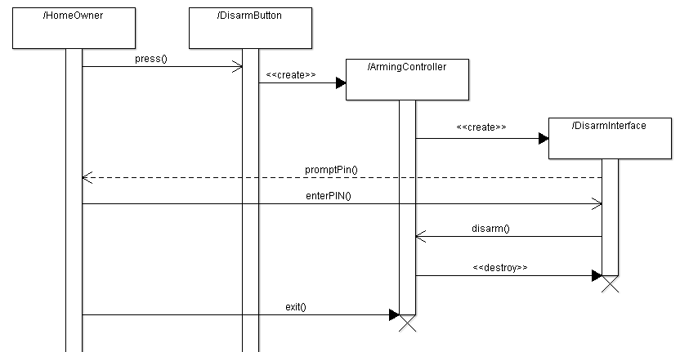

**Application Class Model:**

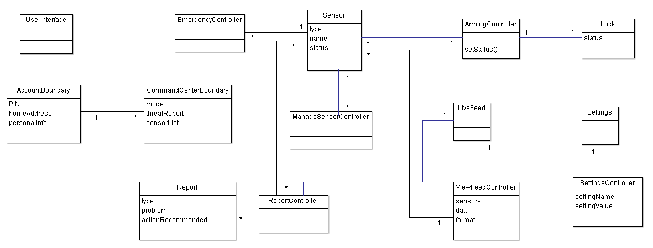

**Application State Model:**

**Emergency Controller:**

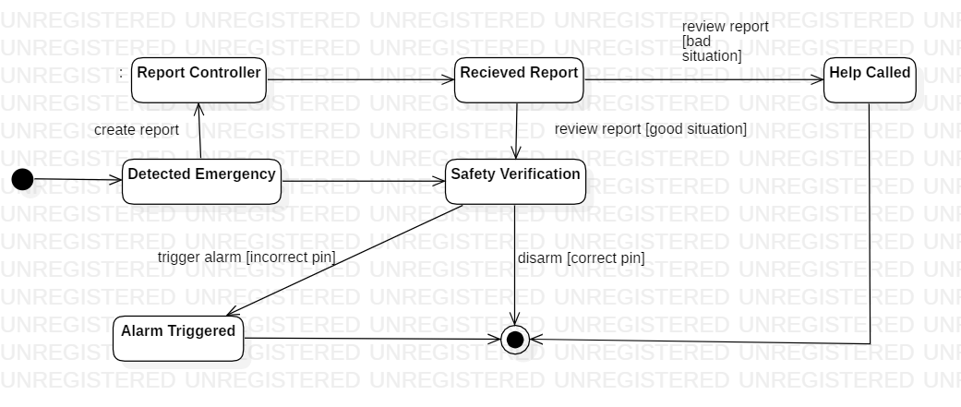

**Arming Controller:**

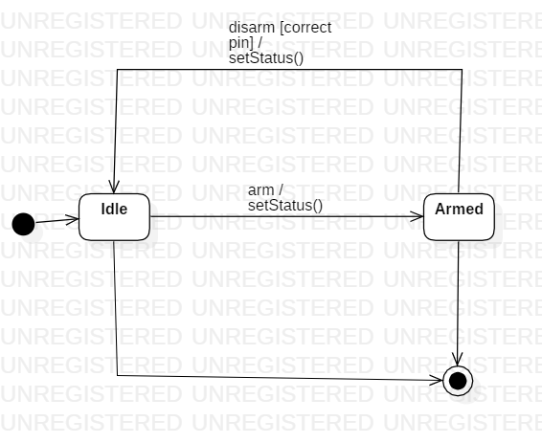

**System:**

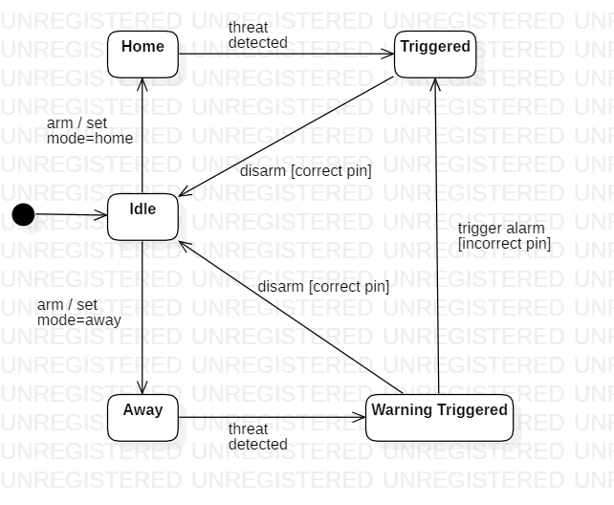

**Report Controller:**

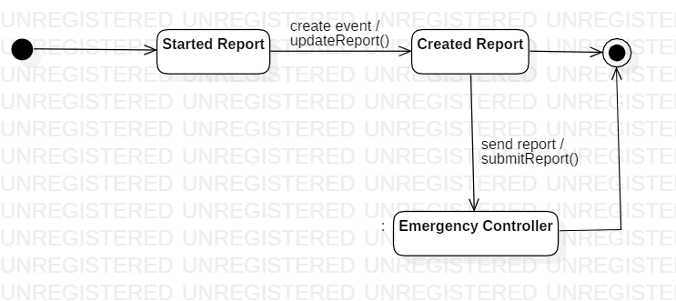

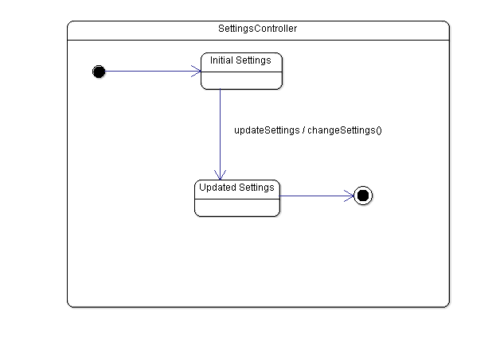

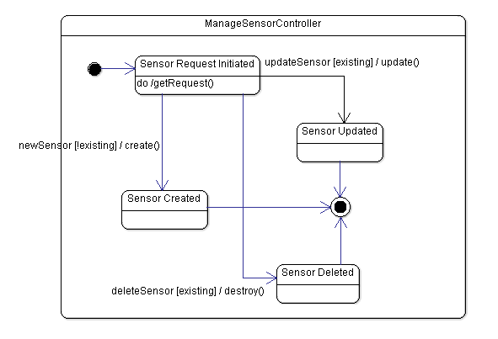

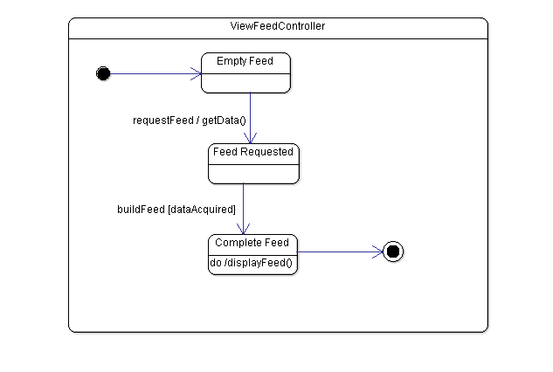

**Consolidated Class Model:**

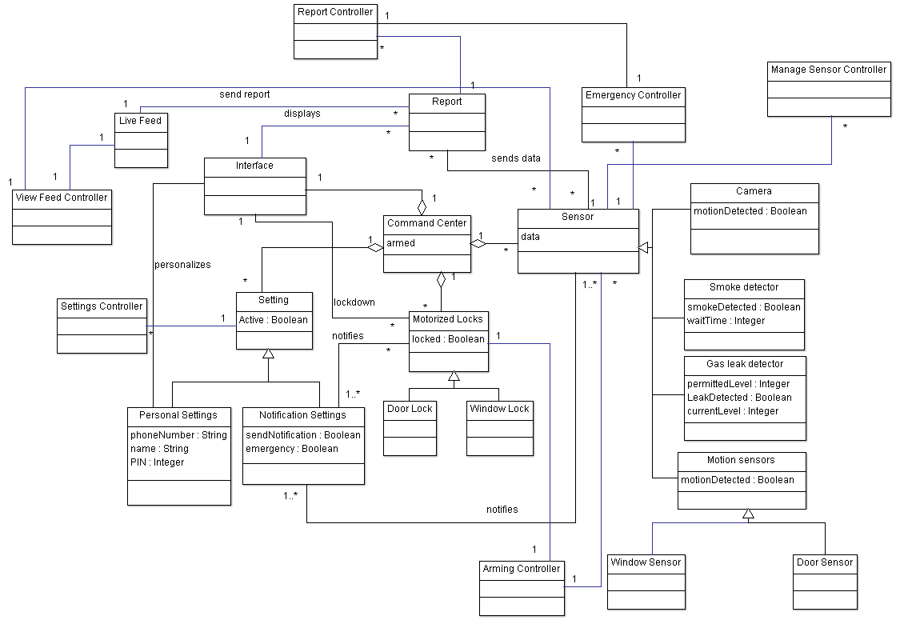

**Model Review:**

**Class Domain Model**

* Completeness
  + To ensure the model was completed, we used linguistic analysis on our concept statement and highlighted all the important classes and attributes to put into our model. This ensured that every part of our system was covered.
* Consistency
  + To ensure consistency, we covered all of our concept statement and made sure every important detail was represented in our domain model.
* Correctness
  + The concept statement and class domain model both model the entire system, therefore making them correct.

**Domain State Model**

* Completeness
  + The state model covers all possible states that the system and the sensor could be at, therefore it is complete.
* Consistency
  + When compared to the concept statement and class model, the domain state model does not contain any new information and can only be one state at a time.
* Correctness
  + The state model covers all options for the states to be in and covers all the entry conditions and events.

**Application Interaction Models**

* Completeness
  + The use cases elaborate for each scenario and completely cover all of the scenario’s options.
* Consistency
  + To ensure consistency, we checked all of our use cases with our concept statement and made sure every important detail was represented in both.
* Correctness
  + The use cases directly apply to the situations presented by our system and do not create any new situations previously unpresented.

**Application Class Model**

* Completeness
  + The application class model accurately translates the domain model to a form that can be built with software and follows the application interaction model. Hence it is complete.
* Consistency
  + The application class model is consistent with the domain model and the concept statement, as well as the application interaction model.
* Correctness
  + The application class model correctly solves the problem that the product is designed to solve and designs a correct software solution.

**Application State Model**

* Completeness
  + Our state models covered every controller we implemented and included their actions between states.
* Consistency
  + Our state models represented the information previously presented in the class model without adding anything new that would affect them.
* Correctness
  + Our state models represented the information in the same way that they were previously represented while featuring all the required information about them.